Exp No: 9
ULTRASONIC SENSOR IN PROTEUS USING ARDUINO
AIM:
To write an Embedded C program for interfacing Ultrasonic Sensor using Arduino Uno and Proteus
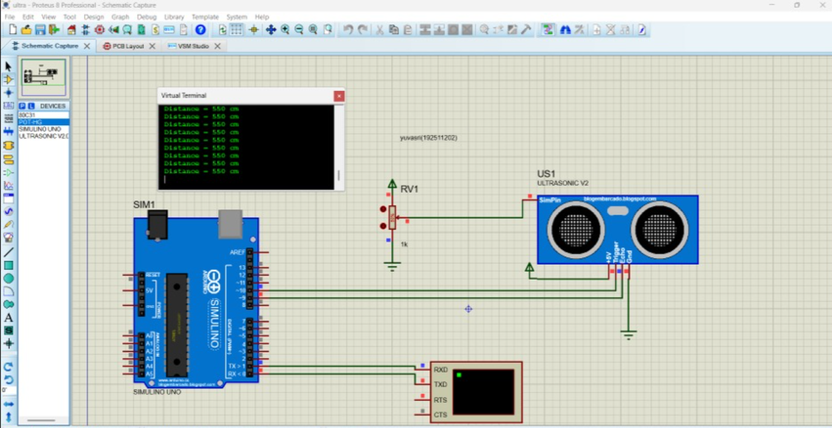
RESULT:
Thus the program has been successfully verified and executed

